波数积分脚本：

#!/bin/sh
set -x
HS=10
#this depth and model gives a spectra hole at 33-40 sec
STK=0
RAKE=0
DIP=45
AZ=45
######
# changing the RAKE to 45 removes some of the spectral hole
# =0 Strike slip if dip is 90
# =90 dip slip is dip is 45 -- good hole
######
cat > dfile << EOF
200.0 0.025 1024 -1.0 10.0
210.0 0.025 1024 -1.0 10.0

EOF
cat > model.d << EOF
MODEL.01
CUS Model with Q from simple gamma values
ISOTROPIC
KGS
FLAT EARTH
1-D
CONSTANT VELOCITY
LINE08
LINE09
LINE10
LINE11
H(KM) VP(KM/S) VS(KM/S) RHO(GM/CC) QP QS ETAP ETAS FREFP FREFS
1.0000 5.0000 2.8900 2.5000 0.172E-02 0.387E-02 0.00 0.00 1.00 1.00
9.0000 6.1000 3.5200 2.7300 0.160E-02 0.363E-02 0.00 0.00 1.00 1.00
10.0000 6.4000 3.7000 2.8200 0.149E-02 0.336E-02 0.00 0.00 1.00 1.00
20.0000 6.7000 3.8700 2.9020 0.000E-04 0.000E-04 0.00 0.00 1.00 1.00
0.0000 8.1500 4.7000 3.3640 0.194E-02 0.431E-02 0.00 0.00 1.00 1.00
EOF
#####
# Chapter 3
#####
hprep96 -M model.d -HS ${HS} -HR 0 -d dfile -ALL
hspec96 > hspec96.out
hpulse96 -D -p -1 4 > file96
fmech96 -A ${AZ} -ROT -D ${DIP} -R ${RAKE} \
-S ${STK} -M0 1.0E+20 < file96 > 3.96
f96tosac -B 3.96
cp B00101Z00.sac Z1.sac
cp B00201Z00.sac Z2.sac

rm B*sac

震源深度 10km；震中距 200km 210km；方位角 45；走向 0；滑动角 0；倾角 45。
采样间隔：0.025s；P波到时：31.01s 32.24s。
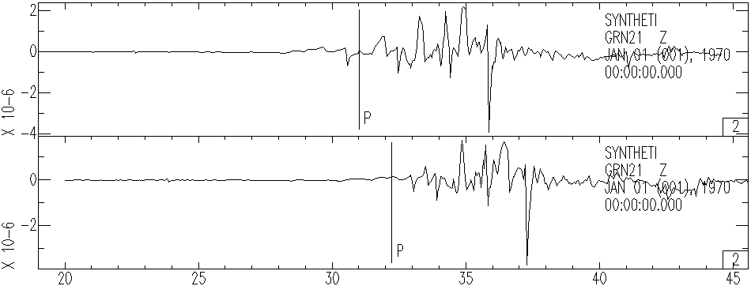
滤波 1~10Hz
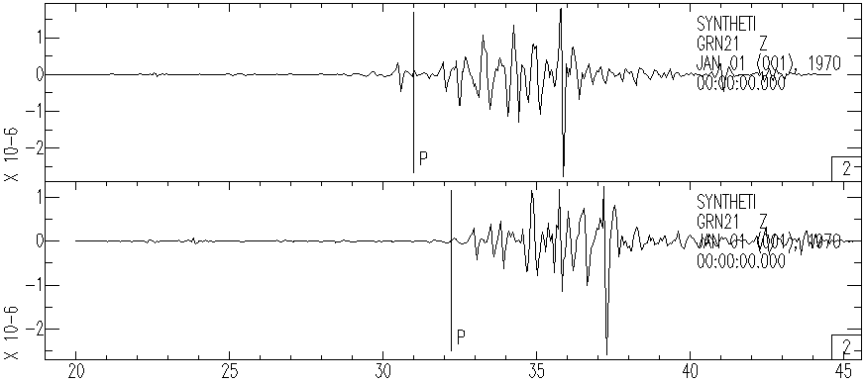
将采样间隔改为0.25s

